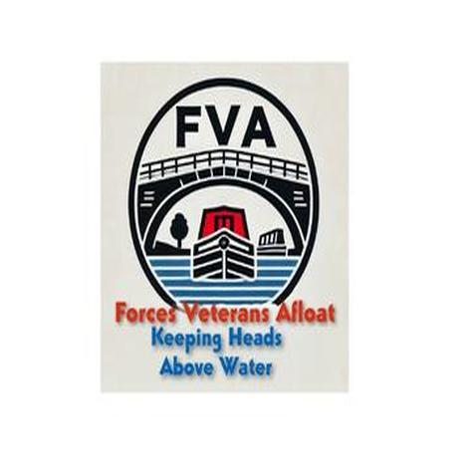
Forces Veterans Afloat – NB Atalanta
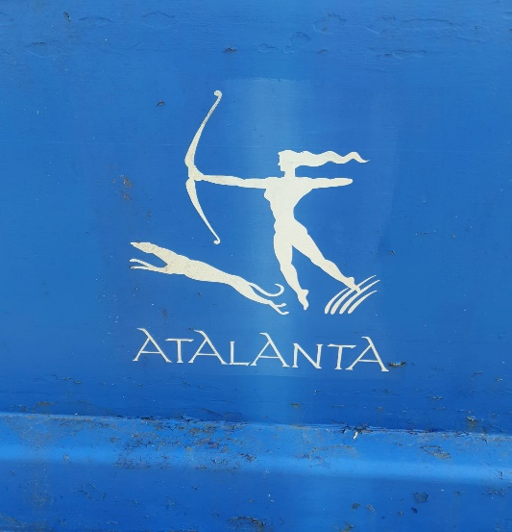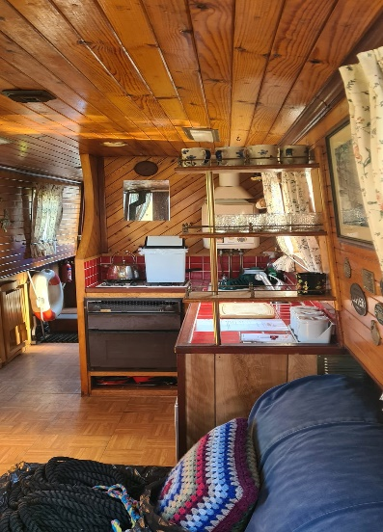
Atalanta is our smallest boat at present at 35ft. She has been occupied until recently and is just coming back into the fleet.
Her most urgent need is external painting and a lip on the stern door to stop water getting in. She is likely to be used in future as a veteran assessment and training boat.

