
Forces Veterans Afloat – CC Susie Splash
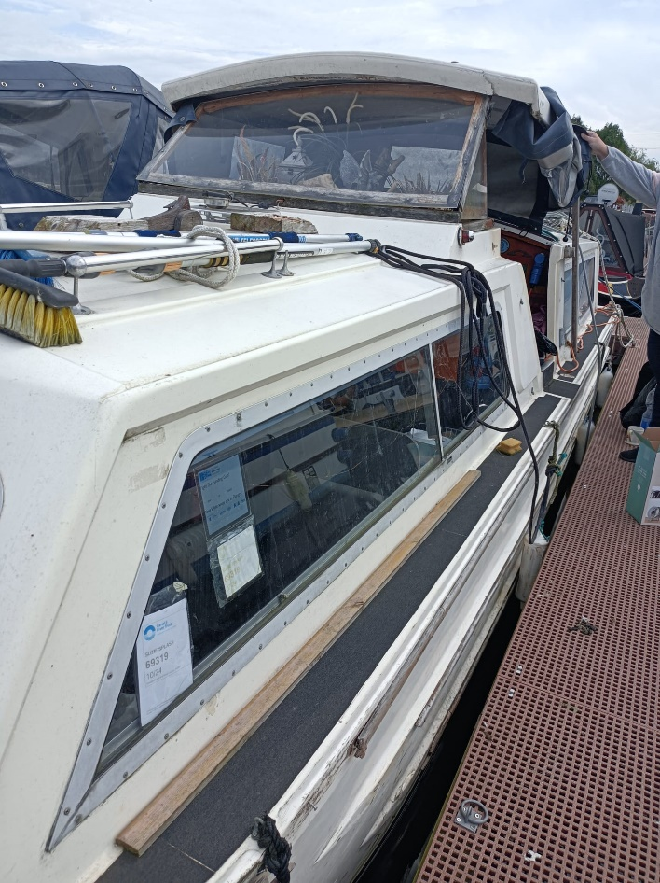
CC Susie Splash is unusual for us, as she is s GRP cabin cruiser. She’s a 29ft Creighton, with a centre cockpit. She’s another grand old lady – having been built in 1968! Her excellent condition is a testament to how well her previous owners looked after her. She was in such good condition, we couldn’t say no to her just because she wasn’t a narrowboat. She will be used as an assessment boat, marina based as there’s no shower on board and currently, no engine fitted. We love Susie but we don’t intend taking on another GRP, as our knowledge is with steel boats.

