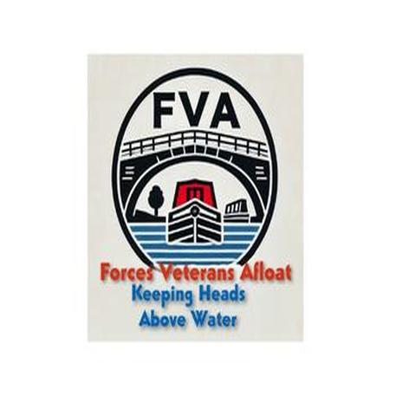
Forces Veterans Afloat – NB SammyB
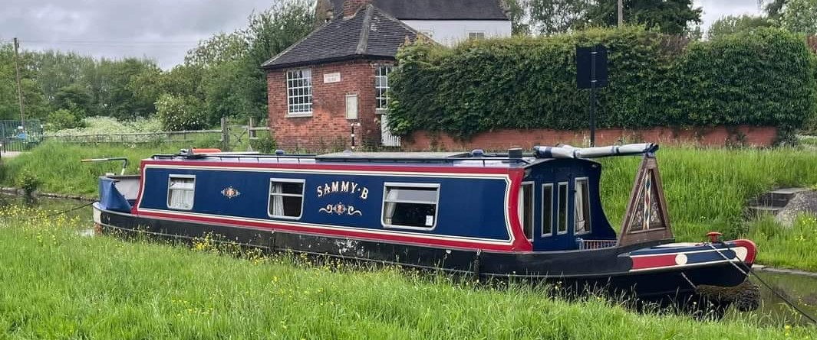
Our SammyB is one of our more unusual donations – in that she was absolutely immaculate when she was given to us. She was built by the people who gave her to us, named after their dog, and they had many happy years on board. They are in regular contact with us and are delighted that SammyB is deployed with a veteran who absolutely loves living on her.

Next year we hope to refresh her paint work, have her out of the water and black her. That will be in the summer when she returns to the fleet after her current deployment.

