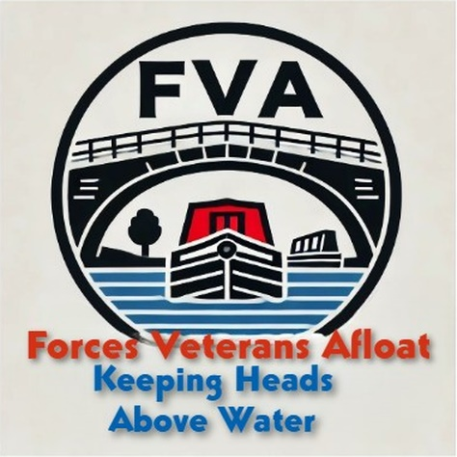
Forces Veterans Afloat – NB Capricorn
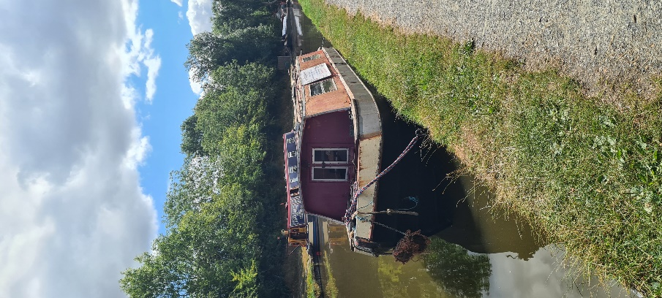Capricorn is our “Barney Boat” – that is that she was built at Braunston in the 1970’s by Chris Barney – often regarded as the grandfather of leisure narrowboats. She’s a Wooden top – meaning her cabin is made out of wood. This wooden cabin now desperately needs replacing, as it is showing its age! We will be re-creating the structure as it was done originally – once a Barney boat, always a Barney boat! This is a huge project and we are currently looking for a sponsor to help us with her.

