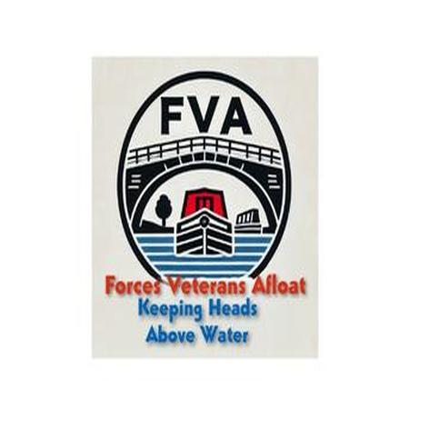
Forces Veterans Afloat – NB Stingray
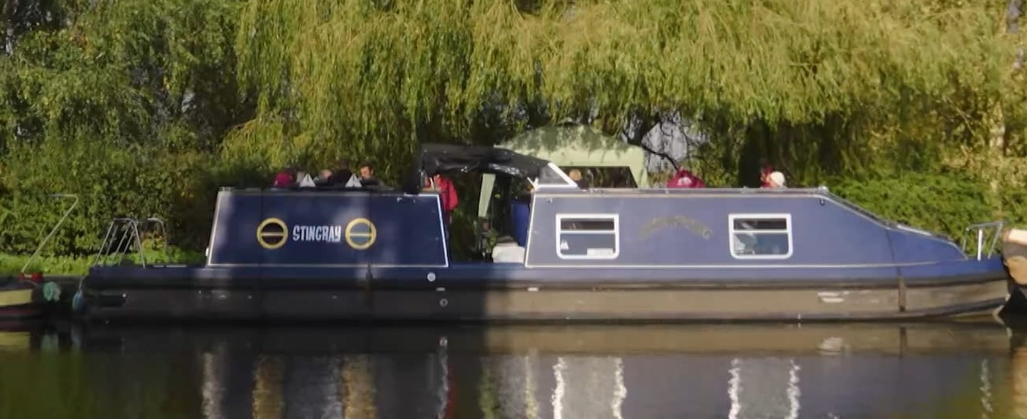
Meet our glamour-girl and TV star – NB Stingray. You may have seen her and Jay, the veteran who she’s deployed with, in Channel 4’s “Narrow Escapes”.
Stingray is very unusual. She is a Seaotter – which are aluminium boats instead of steel. They made quite a lot of 32ft centre cockpit versions but there was a myth that a 41ft version had been built, although no-one knew where it was or even if it actually existed. Imagine the excitement when we realised that we had been given the fabled boat! She is one-of-a-kind, number 1 on the plans and as far as we know, there isn’t another 41ft like her around.

