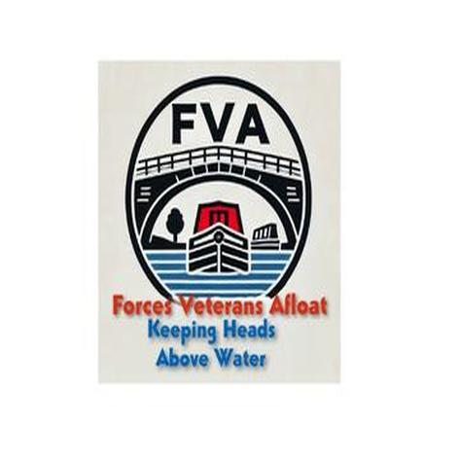
Forces Veterans Afloat – NB Daisy
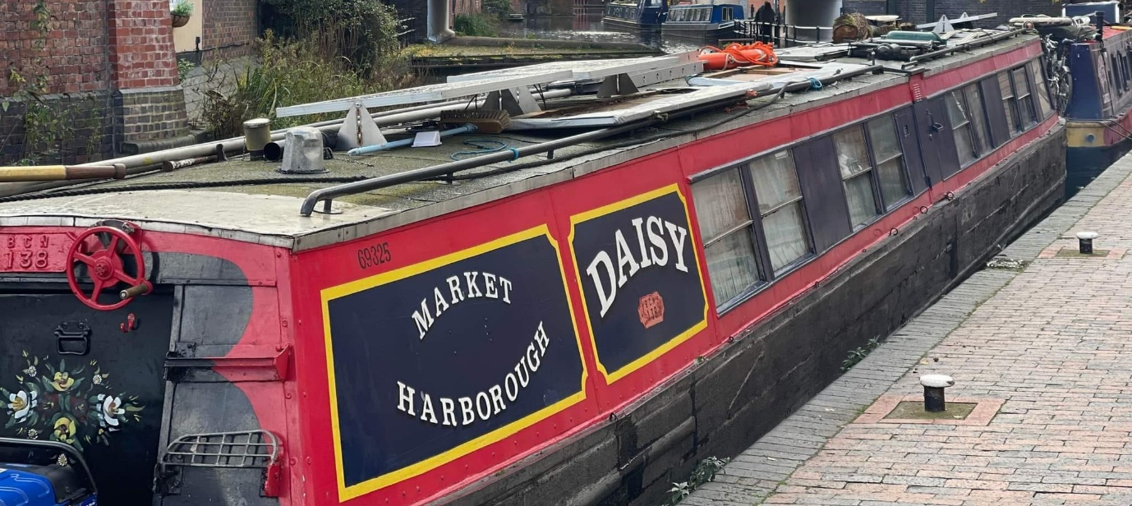
This is our flagship – a 104-year-old former Midlands coal butty, built in 1921. She was given to us by 2 couples who bought her in the 80’s, & made her their holiday boat. They took her pretty much everywhere on the system where she would fit in to the locks!
She is 70 ft long – she was 72ft but they shortened her. She has wind down windows from a Birmingham tram and is lined with highly varnished wood from a bank board room!
She is heavy and has a mind of her own, so she won’t be deployed – she’ll be used as an office, canteen, meeting room and overnight accommodation for volunteers. She is in need of refurbishment. We will work on her when we don’t have a boat to get ready for a veteran.

