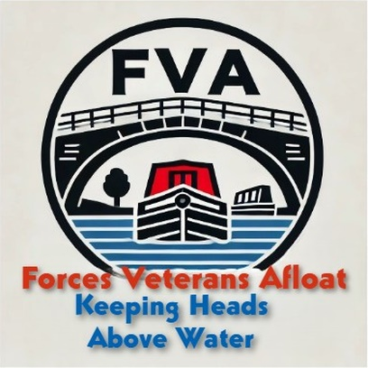

Forces Veterans Afloat – NB Madeley Wood
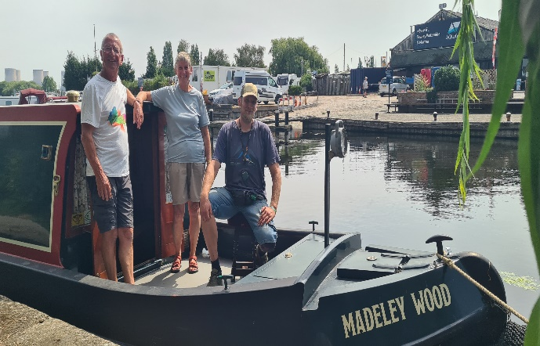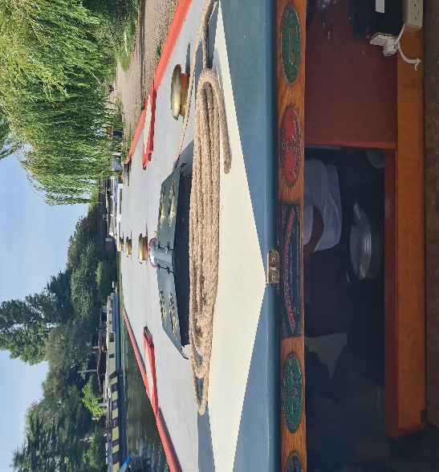

Madeley Wood is our most recently donated boat and she is an absoluter smasher! She’s 42 feet long, traditional stern, with reverse layout – galley, convertible dinette, bathroom, saloon with stove and a tug bow deck.

She is 30 years old and was built for John and Barbara, who you can see in the picture on the left. She is in such immaculate condition that we have been able to deploy her straight away – the veteran on board loves her already.

