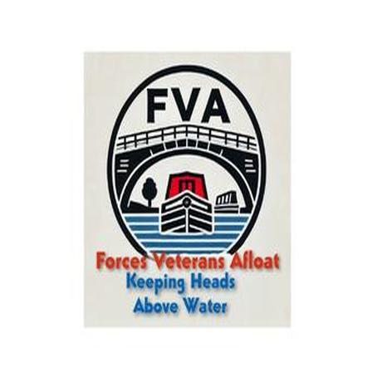

Forces Veterans Afloat - NB Clover
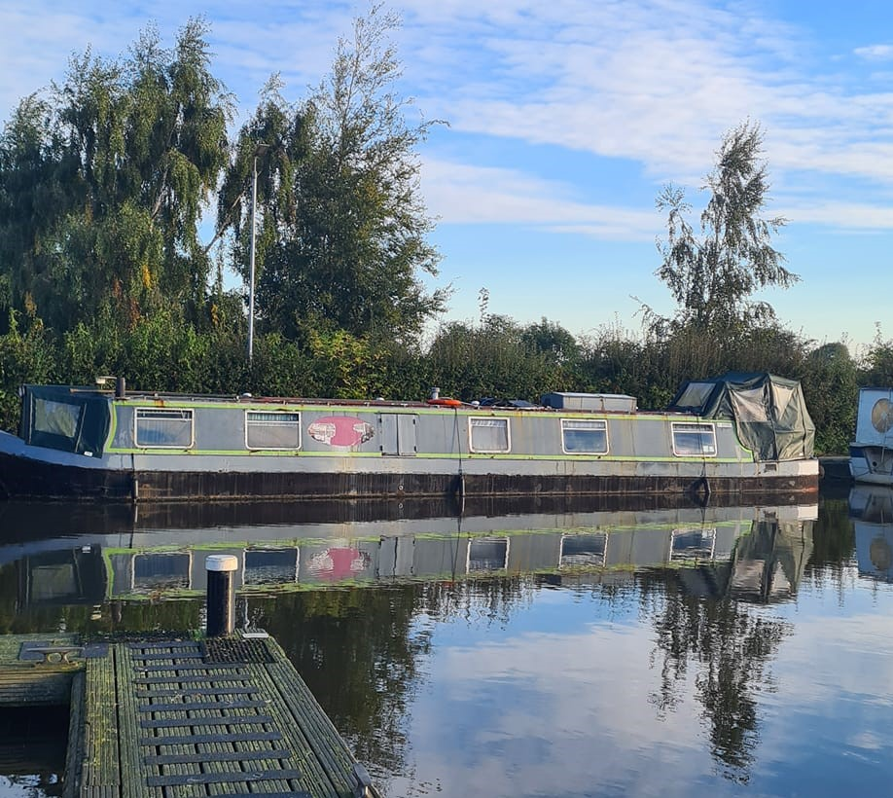

NB Clover was acquired through the Responsible Boat Rehoming Company. She had been owned by a veteran – so they felt it very appropriate that she came to us.
At 57 feet she is the biggest boat we will have available for deployment. She requires total refurbishment, which should start soon.
She is to be adopted by the charity – The Longest Yarn and re-named “ Clover - The Longest Yarn”

